4.4 Surface Area; Parametric Surfaces Worksheet

- Consider the surface given by which lies in the first octant. Determine the exact surface area of .

- Consider the surface given by which lies below the plane . Determine the exact surface area of .

- Consider the surface determined by where and .
  - Set up an iterated integral which computes the surface area of this surface.

  - Find a parameterization of the surface.

  - Set up an iterated integral which computes the surface area of this parameterized surface.

- Consider the part of the graph where and .
  - Set up an iterated integral which computes the surface area of this surface.

  - Find a parameterization of the surface.

  - Set up an iterated integral which computes the surface area of this parameterized surface.

- Consider the surface with the parameterization with and .
  - Sketch a picture of and determine its surface area algebraically.

  - Set up an iterated integral which computes the surface area of and confirm that it evaluates to the surface area you found in part (a).

  - Can this surface be presented as a function ?

- Consider the surface with the parameterization with and .
  - Sketch a picture of and describe its shape.

  - Set up an iterated integral which computes the surface area of and calculate this integral.

  - Find a way to write express as two functions of the form

  - Determine the surface area of using functions you found in part (c) and confirm that your result matches the result from part (b).

- Consider the surface parameterized by for ,
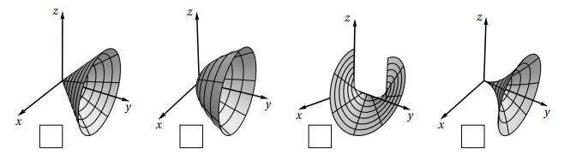
- Mark the box below which corresponds to the picture of .

- Set up an iterated integral which computes the surface area of .

- Consider the surface parameterized by for ,
- Mark the box below which corresponds to the picture of .
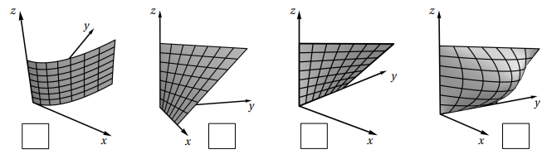

- Set up an iterated integral which computes the surface area of .

- Express as a function in terms of x, y, & z.

- Consider a cylindrical can of radius 4 and a height of 5 (including top and bottom).
- Create a parameterization of these surfaces, you will need 3 parameterizations in total. Note: Infinitely many parameterizations exist.

- Set up iterated integrals to compute the surface area of each of the three surfaces from part (a) to determine the surface area of the entire can.

